

American International University-Bangladesh (AIUB)  
Department of Computer Science and Engineering   
Faculty of Science &Technology (FST)  
Spring 2022-2023

HUMAN COMPUTER INTERACTION

Section: D

**Design and Development of a Wearable Game Controller Using Arduino for PC Games**

**Submitted by:**

|  |  |
| --- | --- |
| **Name** | **ID** |
| ***PRITOM DEBNATH*** | *20-42414-1* |
| ***NEBADETA NATH TONNEY*** | *19-39809-1* |
| ***PRANAY ACHARJEE*** | *20-42372-1* |
| ***RAFID, KAFIL WARA*** | *18-38175-2* |
| ***MD. RAHATUL HASAN RAHAT*** | *20-42685-1* |

**Submitted to:**

DR. MUHAMMAD FIROZ MRIDHA

Faculty of Science and Technology

**1. Abstract:**

In this project, we propose a system for controlling a racing game using a wearable glove equipped with a Flex Sensor interfaced with an Arduino Uno board. The system aims to provide a more natural and immersive gaming experience by allowing users to control the game using hand gestures. The glove captures the wearer's finger movements, and the Flex Sensor sends this information to the Arduino Uno board, which processes the data and sends the corresponding control inputs to the computer running the game. The system provides a low-cost, easily accessible way to enhance the gaming experience and promote physical interaction with digital games.

**2. Introduction:**

Gaming has become increasingly popular over the years, with advancements in technology enabling new ways to interact with games. One of the challenges with traditional game controllers is their limited range of motion and lack of naturalness. Researchers have explored various approaches to overcome these limitations, including the use of flex sensors in wearable gloves. The concept of using flex sensors for controlling robotic grippers was introduced in previous works [1]. Another study explored the use of wearable game controllers that combine physical and digital interactions [2]. Additionally, research has been conducted on using hand gestures for PC games [3]. In this project, we aim to develop a system that combines the benefits of these previous works. Our system utilizes flex sensors in wearable gloves to detect hand movements, which are then translated into corresponding game commands on the PC. The flex sensors are sensitive to hand gestures and provide a natural way to control the game. This approach can enhance the immersive gaming experience and provide players with a more intuitive way to interact with the game. Our work builds on previous research in the field and aims to contribute to the development of wearable gaming technology that can be used to enhance the user experience.

**3. Methodology:**

**3.1 Components**

* **Hardware:**
* Arduino Uno
* Flex Sensor
* Accelerometer
* Battery
* Cables
* Gaming console
* **Software & Tools:**
  + Game
  + Arduino IDE
  + BlueStacks

***Arduino Uno***: The Arduino Uno is a popular microcontroller board based on the ATmega328P microcontroller. It has 14 digital input/output pins (6 of which can be used as PWM outputs), 6 analog input pins, and a USB connection for programming and communication with a computer.

The Uno board is easy to use and can be programmed using the Arduino software, which is an open-source integrated development environment (IDE). The software uses a simplified version of the C++ programming language and provides a user-friendly interface for writing, compiling, and uploading code to the board.

The Uno board is commonly used in various DIY projects, including robotics, home automation, and interactive art installations. It is also a popular choice for educational purposes, as it is affordable, easy to use, and has a large community of users who share their knowledge and projects online.

|  |
| --- |
| Figure1: Arduino Uno |

***Flex Sensor:*** A Flex Sensor is a type of sensor that changes its resistance when it is bent or flexed. It is a thin, flexible component that is typically made of a polymer material with conductive particles embedded in it. The resistance of the flex sensor changes in proportion to the amount of bend or flex it experiences. Flex sensors are commonly used in applications where changes in bending or flexing need to be detected, such as in robotics, medical devices, and gaming controllers.

|  |
| --- |
| Figure2: Flex Sensor |

***Accelerometer:*** An accelerometer is a sensor that measures acceleration and tilt in three axes (X, Y, and Z). It consists of a mass suspended by a spring that moves relative to a fixed frame when the sensor is subjected to acceleration or tilt. The relative motion between the mass and frame generates an electrical signal that is proportional to the acceleration or tilt. Accelerometers are commonly used in many applications, including motion sensing, vibration measurement, navigation, and gaming. They are used in smartphones and other portable devices to detect screen orientation, shake, and tap gestures. In gaming, accelerometers are used to detect the movement of the game controller, providing a more immersive and interactive gaming experience. In this project, we are using the ADXL335 Accelerometer to detect the movement of the game controller for controlling a racing game.

|  |
| --- |
| Figure 3: Accelerometer |

***BlueStacks:*** BlueStacks is an Android emulator software that allows users to run Android applications on a computer. It creates a virtual Android device on the computer and allows users to download and install Android apps from the Google Play Store. BlueStacks can run on both Windows and Mac operating systems and provides a user-friendly interface that resembles the Android interface. It enables users to use a keyboard and mouse to navigate the Android apps, making it an ideal tool for playing Android games on a computer. BlueStacks also provides support for game controllers, allowing users to connect external controllers to the computer and use them to control the games.

**3.2 Circuit Diagram:**

**Hardware Setup:** The sensors are connected with Arduino uno. Communication medium from the uno to game is bluestacks software. Used components are compatible with each other.

Accelerometer

Flex sensor

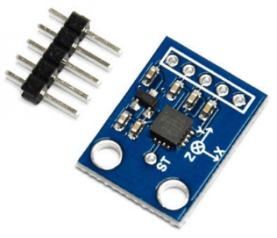

Arduino Uno

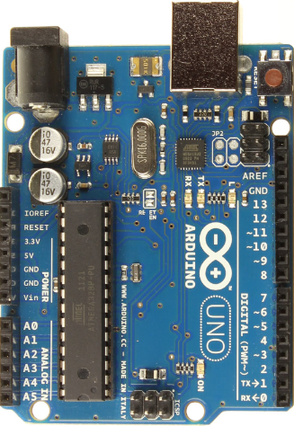



Output



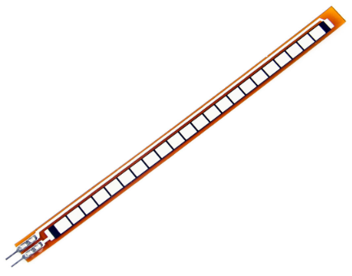

Computation

Figure 4: System block diagram

**3.3 Software Installation:** To install the necessary software for the project, BlueStacks was downloaded and installed from the official website. The Arduino IDE was downloaded from the official website as well. The necessary libraries for interfacing the Flex Sensor and Accelerometer with the Arduino Uno were downloaded from their respective websites. Once the software was downloaded, the necessary drivers for the Arduino Uno were installed by following the instructions provided by the Arduino website. Finally, the BlueStacks software was configured to receive input from the Arduino Uno by mapping the sensor readings to corresponding game controls.

**3.4 Sensor Calibration:** Before using the sensors, they were calibrated to ensure accurate readings. The Flex Sensor was calibrated by recording the minimum and maximum resistance values when the sensor was at rest and fully bent. The Accelerometer was calibrated by recording the values in three axes when the sensor was at rest.

**3.5 Mapping Sensor Readings:** The sensor readings were mapped to corresponding control inputs for the racing game in BlueStacks. This involved using software to convert the analog signals from the Flex Sensor and Accelerometer into digital signals that could be interpreted by the racing game.

**3.6 Testing and Debugging:** Once the system was fully assembled, we tested it and debugged any issues that arose. This involved running the racing game and using the Flex Sensor and Accelerometer to control the game character.

**4. Features:**

* Controlling game
* Compatibility with other games
* User-friendly interface
* Customizable control mapping

**5. Prototype Image:**

|  |
| --- |
| Figure 5: Prototype |

**5. Advantage:**

Wearable controller has many advantages, these are listed below:

* Improved Gaming Experience: Using the Flex Sensor and Accelerometer, the project offers a new and immersive way to control the game character, providing a more engaging and enjoyable gaming experience.
* Cost-Effective Solution: Compared to expensive commercial gaming controllers, this project provides a cost-effective solution that utilizes affordable sensors and components, making it accessible to a wider audience.
* Customizable Controls: The project allows for customization of the game controls to suit individual preferences, offering a personalized gaming experience.
* Portable Design: The wearable gloves and compact Arduino Uno design make the project highly portable, allowing for easy transportation and use in various locations.
* Versatile Application: The Flex Sensor and Accelerometer can be used for a wide range of applications beyond gaming, such as in medical and industrial fields for motion sensing and control.
* Innovative Use of Technology: The project showcases the innovative use of technology to create a novel solution for gaming control, demonstrating the potential of emerging technologies for solving real-world problems.

**6. Conclusions & Future Works:**

The design and development of a wearable game controller using Arduino for PC games is an innovative and exciting area of research that has the potential to enhance the gaming experience for players. Through the use of Arduino microcontrollers and various sensors, players can create unique and customized gaming accessories that are tailored to their individual needs and preferences. This article has provided a comprehensive overview of the design process, including the selection of materials, the integration of sensors, and the programming of the Arduino microcontroller. Furthermore, it has highlighted the importance of thorough testing and validation to ensure the functionality and reliability of the game controller. Overall, the development of a wearable game controller using Arduino for PC games is a promising field of research with many potential applications in the gaming industry.

In terms of future work, several areas of improvement can be explored. One potential avenue for future work is to incorporate additional sensors or improve the sensitivity of the existing sensors to provide even more nuanced control over games. Another area of improvement could be the development of a more sophisticated algorithm to detect and interpret hand movements. Additionally, the design of the wearable game controller could be refined to improve ergonomics and make it even more comfortable to wear for extended periods of time.

**Reference:**

[1] Roy, K., Idiwal, D. P., Agrawal, A., & Hazra, B. (2015, July). Flex sensor based wearable gloves for robotic gripper control. In Proceedings of the 2015 Conference on Advances in Robotics (pp. 1-5).

[2] Richard, G. T., & Kafai, Y. B. (2015). Responsive make and play: youth making physically and digitally interactive and wearable game controllers. More Playful User Interfaces: Interfaces that Invite Social and Physical Interaction, 71-93.

[3] Noor, N. M. M., Ng, A. A. A., & Rohidatun, M. W. (2022, August). Hand gesture-based flex sensor for PC games. In 8th International Conference on Mechatronics Engineering (ICOM 2022) (Vol. 2022, pp. 16-20). IET.